**Instructions for Zapcodes**

ZapWorks (<https://zap.works>)

You will need:

1. Smartphone, either Android or Apple.
2. Computer or laptop.
3. App reader for the Zapcodes.

How to access the **free** Zappar app.

Access either the Apple App Store or Google Play.

https://www.zappar.com/static/v-77372dd6/img/app_store.pnghttps://www.zappar.com/static/v-77372dd6/img/play_store.png

Type Zappar in the search bar to access the app.

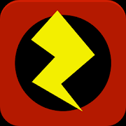

Download and install.

Once the app is installed, open it and aim (like reading a QR code) at the symbol.



Once you see the images appear and the music plays, touch the rotating circles one at a time. Swipe your finger across the pictures to see each one. Touch the web pages and look around.